Ball High Choir Booster Club
4115 Ave O
Galveston, Texas 77550
ballhighchoirboosters@gmail.com

Dear Community Sponsor,

The Ball High School Choir is looking for Sponsors for the 2022-2023 school year. We are a growing program and would love for you to consider becoming a Sponsor for our group. The Ball High School Choir Program consists of three ensembles: Tornado Tenor-Bass Chorus, Tornado Treble Makers, and the Tornado Golden Voices. We range from a Beginner-Intermediate choir in our first-year ensembles, to our Advanced Choir in our upperclassmen group. Our Choirs participate in UIL events and have opportunities to represent GISD at the State level.

All proceeds from the sale of the printed programs and sponsorships directly support the Ball High
School Choir. These proceeds will fund local performances, guest voice instructors, summer choir camp activities, travel expenses, and student scholarships. We are excited about the growth of our program and look forward to getting more support from local families and businesses.

Ad prices and sponsorship levels are listed on the attached form and you may also find information on our website. Please provide artwork in the highest resolution and in jpeg form when possible. Please also submit your artwork online to: ballhighchoirboosters@gmail.com and/or larrianmenifee@gisd.org

We appreciate your support of the Ball High School Choir and look forward to your participation.

Thank you for your support,

Leah tuten Larrian Menifee
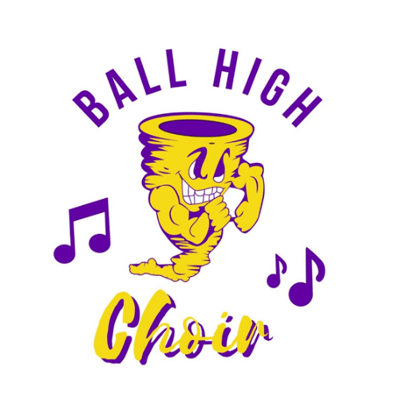
Booster Club President Choir Director

2022-2023 Ball High Choir Sponsorship & Ads

Sponsorship Levels

Conductor $500.00
Up to 12 reserved seats at Concerts
Up to 4 BHS Choir Shirts
Full Page Ad in all programs (Fall and Spring Concerts)
Advertised on ball high choir website
Inclusion in Choir social media platform
8x11 ½ certificate to display in your business or home
Recognition at the annual Choir Banquet

Whole Note $200.00
Up to 8 reserved seats at Concerts
Full page Ad in all programs (Fall and Spring Concerts)
Note: Sponsorships are year round whereas advertisements are by the semester.

Inclusion in Choir social media platforms
Name and/or logo on homepage website

Half Note $100.00
Up to 6 reserved seats at Concerts
Half page ad in all programs (Fall and Spring Concerts)
Quarter Note $75.00
Up to 4 reserved seats at Concerts
¼ page ad in all programs (Fall and Spring Concerts)
Eighth Note $50.00
Up to 2 reserved seats at Concerts
Name listed in all programs (Fall and Spring Concerts)

---OR---

Ad Prices
Full Page: $100.00 Half Page: $70.00 Fourth Page: $40.00
Eighth Page: $25.00 (business card size)

2022-23 Ball High Choir Sponsorship & Ads

Business Name: Contact Name: Contact Email: Sponsorship Level: Ad Size:
# of tickets needed:

Student Supporting:
Payment Type:

(we accept cash, check, or venmo. Electronic invoicing is also available)

venmo: @ballhighchoir

Checks and forms may also be mailed to: Ball High School Choir Booster Club
4115 Ave O
Galveston, Texas 77550

